iOS Bootcamp 2022

The aim of this exercise is to create a mobile app that helps with displaying NASA’s Astronomy picture of the day

The basic feature set would be -

* Allow users to search for the picture for a date of their choice. You may also get videos in response. Please make add a feature to play video
* Allow users to create/manage a list of "favourite" listings [ Core-data / Sqlite]
* Display the date, explanation, Title and image/video of the day
* Dark mode support
* The app should handle different screen sizes, orientations

You will use NASA’s open APIs ( <https://api.nasa.gov/> ) and in particular, the APOD ( Astronomy picture of the day ) resource.

You are free to choose any third-party libraries, but we expect you to understand their internal implementations and trade-offs if you choose to use them. Also, expect questions about how you would implement similar features if these libraries were unavailable.

Things you should be paying close attention

* App stability (Handling of conditions, edge cases, flaky network and so on)
* Optimal memory utilisation, thread safety considerations
* Robustness of code (Structuring of code for extensibility, good coding practices, use of appropriate data structures and algorithms)
* Overall UI look and feel
* PERFORMANCE
* Documentation

**Submission:**

* Upload all code to a **public** **repository** on github.com and share the link as a submission
* A point of contact within the iOS Bootcamp platforms team will start an email thread with you to help resolve any queries during the course of this exercise.

**App wireframe**

**Main page**

* Use tab bar controller
* Add a search option: You can show a calendar. Integrate any third-party

eg : <https://github.com/patchthecode/JTAppleCalendar> [Use SPM]

* Add functionality to cache data and text using Core-data eg.

https://betterprogramming.pub/how-to-save-an-image-to-core-data-with-swift-a1105ae2cf04

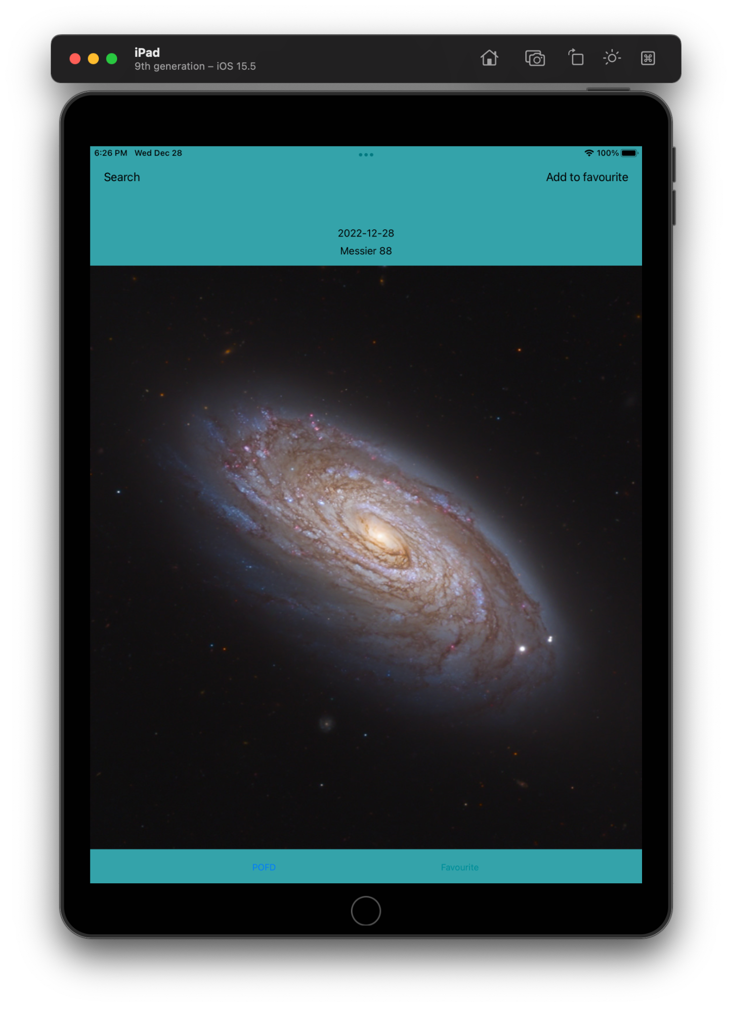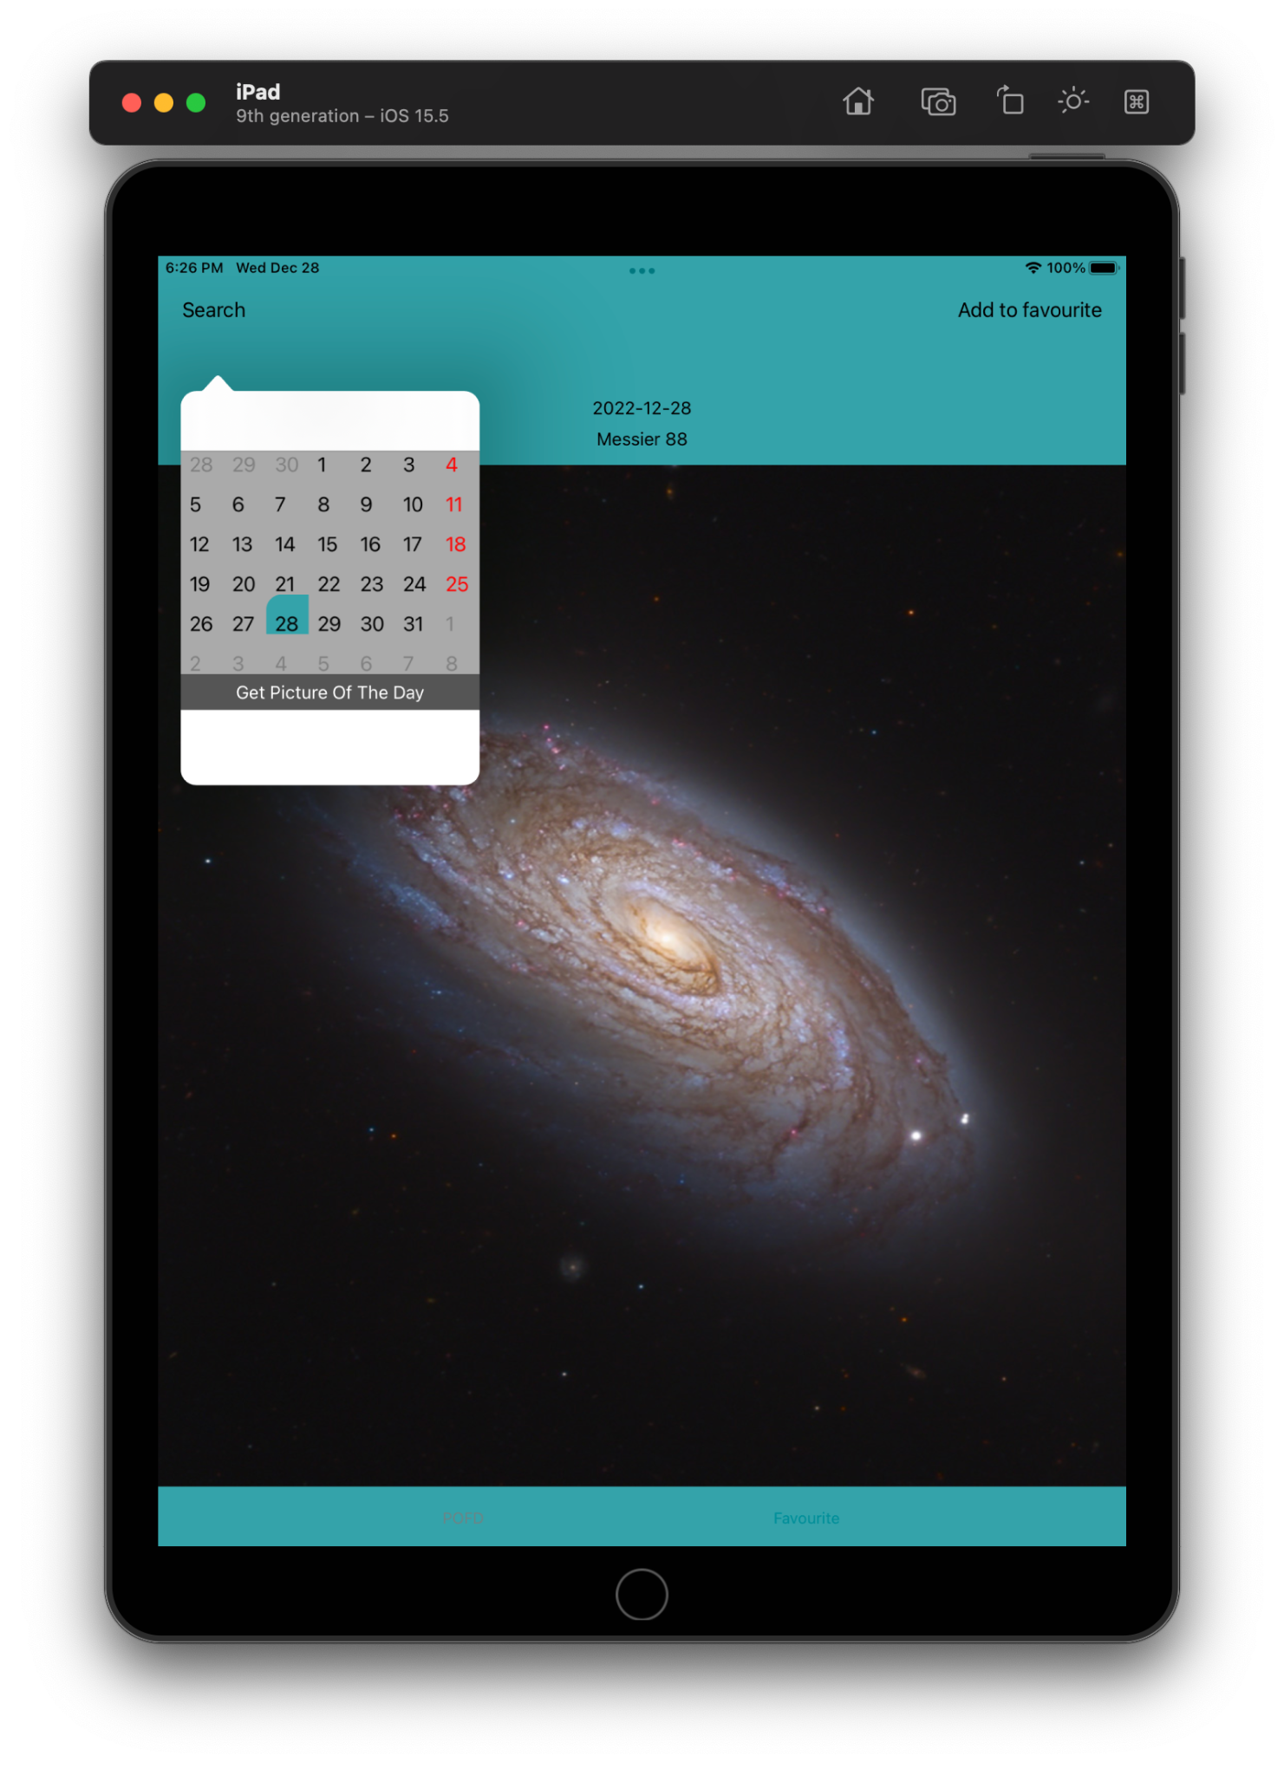

**Details page**   
  
The text should be scrollable more than the display area

Use modal presentation style here

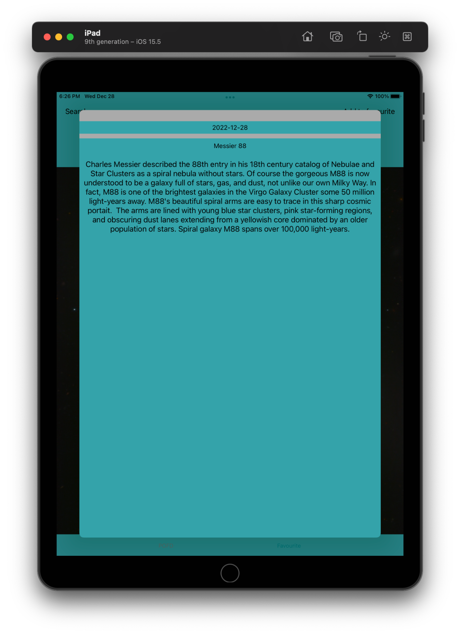

**Favourites page**

* Add a simple table view
* On click of any item, navigate the user to the Details page [Use push animation here]
* This list can be fetched from local storage as well

